Wireframe Document

Heart Disease Diagnostic Analysis

**Last Date of Revision - 10/1/2024**

# Piyush Birle

**Document Control**

|  |  |  |  |
| --- | --- | --- | --- |
| **Date** | **Version** | **Description** | **Author** |
| 1/1/2024 | 1.0 | Introduction, Problem Statement | Piyush Birle |
| 4/1/2024 | 1.1 | Dataset Information, Architecture Description | Piyush Birle |
| 10/1/2024 | 1.2 | Final Revision | Piyush Birle |
|  |  |  |  |

# We Performed Exploratory Data Analysis on Jupyter Notebook and then created a Power BI Desktop Dashboard.

## What Kind of Population do we have?

* 45.87% People suffering from heart disease.

**2) Average Heart Rate By Gender**

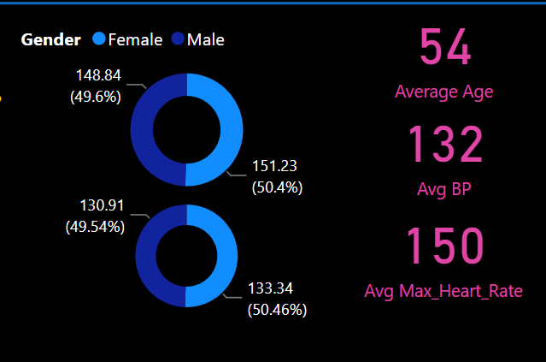

## Who Suffer from Heart Disease?

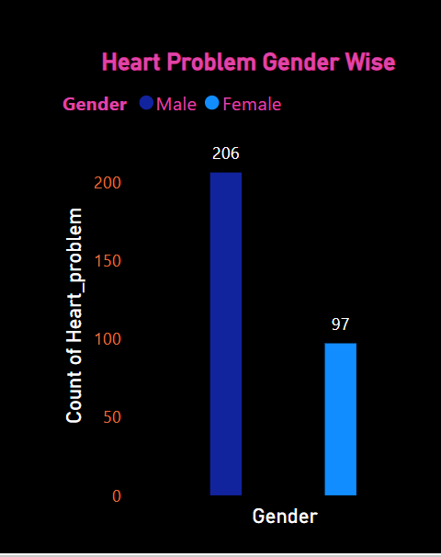

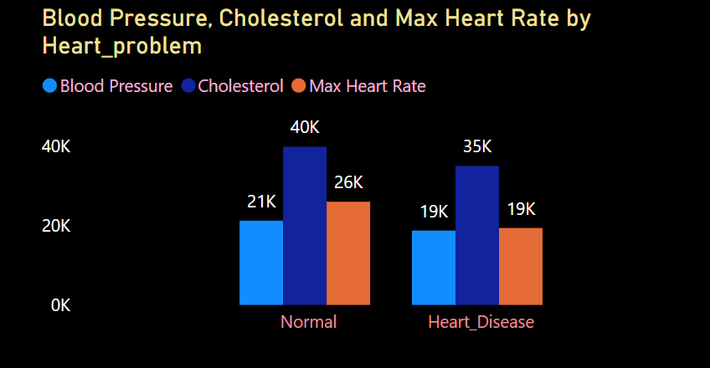

* Males are more prone to heart disease.
* Person who is having More Cholesterol are having high chances of Heart_Disease .

## Count Of Heart Problems By Chest Pain Levels

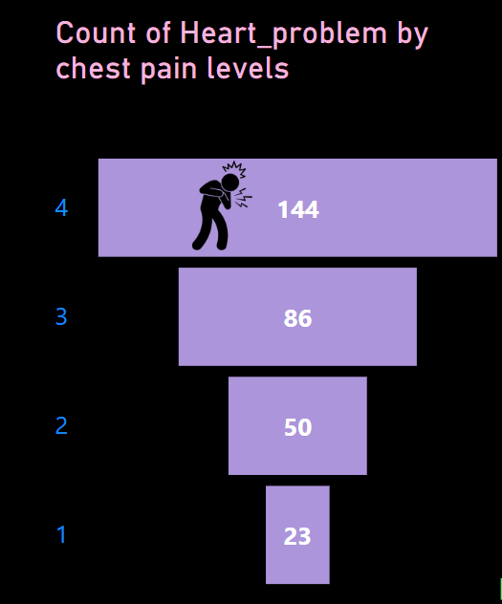

* 144 People Are Having Asymptomatic pain.
* 86 people are having non-anginal pain and rest is typical and atypical.

* Here we can observe that Blood Pressure increases between age of 50 to 60 and somehow continue the pattern till 70.
* Similarly, Cholesterol and maximum heart rate Increasing in the age group of 50-60.

* Between Age 50-60 There are more Number of Females then mens